**Operation Manual**

**Hygiene Process for ANN/LB/CA**

*Ascena Brands*



Table of Contents

1 Document Revision History 3

2 Program Overview 3

2.1 Overview 3

2.2 Functionality and Key Processes 4

2.2.1 Process Overview 4

2.2.2 Hygiene Process Flow 4

2.3 Code and Job Details 6

3 Operational Tasks 9

3.1 Deployment 9

4 Maintenance Tasks 10

4.1 Maintenance Procedures 10

4.1.1 Setting up a new Hygiene Job in Control-M 10

4.1.2 Code Branching 10

4.1.3 Code Review 10

4.1.4 Code Merging 10

4.2 Testing (pre deployment) 10

4.3 Validation (post deployment testing) 10

5 Failure and Recovery Procedures 10

5.1 Troubleshooting 10

5.2 Rerunning EFT or Hygiene Jobs 11

6 Contact Details 11

7 Additional Document References 11

8 Appendix 13

# Document Revision History

| Date | Author | **Revision Description** |
| --- | --- | --- |
| 2019/09/18 | Rajeshwari Ganesan | Initial Version |
| 2019/09/25 | Rajeshwari Ganesan | Added new job setup details |
| 2019/09/30 | Rajeshwari Ganesan | Added ANN and JST job details |
| 2019/10/01 | Rajeshwari Ganesan | Updated the flow diagram |
| 2019/11/19 | Giridhar Velu | Updated the purpose |

# Program Overview

## Overview

|  |  |
| --- | --- |
| **Purpose** | As first step, all files from various sources will land on the EFT server. Few of these incoming files will undergo the Hygiene process in order meet the EDL standards, before moving to the Edge Node. As part of the Hygiene process, functionalities such as Rename the file, Unzip files, Change layout (field positions), XML to text conversion, Filter-out unwanted records, Remove control-M characters, Masking the PCI details of the European customers etc. are taken care of. |
| **Document Scope** | This operation manual will contain documentation regarding the core components of Hygiene process in the files (applicable only to specific files) before transmission to the Edge Node for all files (all brands). Documentation on proceeding or succeeding processes or programs will not be included in this operation manual. However, proceeding or succeeding documentation may be referenced. |

## Functionality and Key Processes

### Process Overview

Some of the data files need to go through custom hygiene processes to prepare them for ingestion into the staging database in Hive. The hygiene process is developed in Unix Shell Scripting and Java. These scripts are executed using Control-M scheduler.

Processes taken care by hygiene jobs:

* Pull the file from EFT INPUT PATH
* Rename the file name *(if needed)*
* Unzip the input file *(if needed)*
* Change the field positions (if needed)
* Split the files (if needed)
* XML to text conversion (if needed)
* Filter-out unwanted records (if needed)
* Remove control-M characters
* Masking the PCI details of the European customers *(if needed)*
* Creates control file
* Push the processed file to EFT OUTPUT PATH
* Removes the input file from EFT INPUT PATH

Then the EFT job will encrypt the file and push it to EDL along with the control file for the data ingestion process.

### Hygiene Process Flow



Figure 1 – High Level Process Flow of Hygiene Process

Hygiene jobs use Control-M for scheduling and execution. Once run, they will pull the decrypted source file from EFT server over the to the hygiene server, run the processes internally, and then move the file out to a PROCESSED_FILES directory on the EFT server.



Figure 2 – Hygiene Process Flow in Detail

#### Masking the customer PCI details

This process will encrypt the below customer PCI details of all European customers. This process is developed using Java and Oracle Database.

* Name
* Address
* Phone number
* Email ID

**Executable Jar:** /app/prod/scripts/job/JAR/DATAMASKING/masking_fixpos_prod.jar

**Server:** l00plmfeapp01.corp.local

Masking process uses an Oracle Table to decide the fields that needs masking in a specific file. If there is no entry available in this table for a particular file, then masking will not be done in that file. If an entry exists in the table, then the Java program gets the details of all the PCI fields/columns which needs masking. Then those fields alone will be masked and the output file will be generated in the work-path. This file will undergoes further processing if needed and then pushed to EFT OUTPUT Path.

**Oracle DB Details:**

**Server:** l00plmfedb01.corp.local

**Database:** mfeprod1

**Table Name:** MASKING_MASTER

|  |  |
| --- | --- |
| **Field Name** | **Data Type** |
| FILE_NAME | VARCHAR2(200) |
| FILE_ID | NUMBER(38) |
| FILE_TYPE | VARCHAR2(20) |
| FIELD | VARCHAR2(60) |
| FIELD_TYPE | VARCHAR2(1) |
| START_POSITION | NUMBER(38) |
| END_POSITION | NUMBER(38) |
| FIELD_NUMBER | NUMBER(38) |
| FL_IDENTIFIER | VARCHAR2(1) |
| MAX_LENGTH | NUMBER(38) |

**Table Structure:**

## Code and Job Details

**Server:** l00plmfeapp01.corp.local

**Code Path:** /app/prod/scripts/job

**Work Path:** /data/prod/CEM

**Script Files:**   
 **Plus:** lbca_process_20190620_new_eft_hostname.ksh

**Premium:**

ann_ads_recordtype_masking_20190701_new_eft_hostname.ksh

ann_masking_20190701_new_eft_hostname.ksh

ann_xml.ksh_new_hostname

ann_process_20190620_new_eft_hostname.ksh

ann_hygiene_20190702_new_eft_hostname.ksh

ann_hygiene.ksh

This script requires the file name as parameter to decide the input path, input filename, output path and output filename in EFT server.

All the details about the hygiene jobs are available in the master excel for more details.

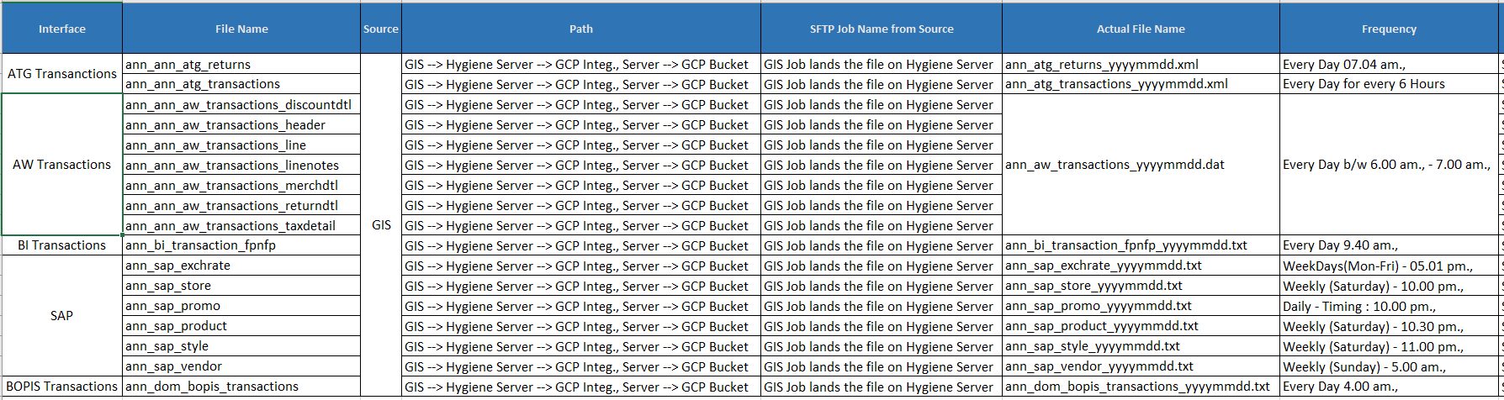

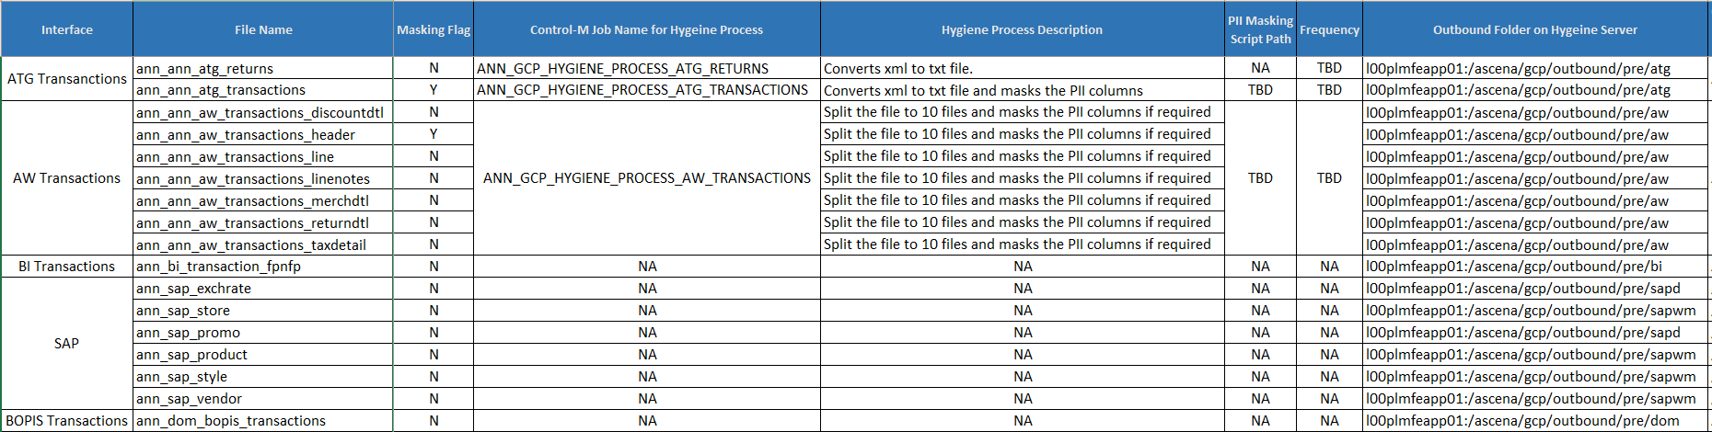

Table 4 – Screenshots from master GCP workbook

# Operational Tasks

## Deployment

Currently the code is deployed in the below path on the hygiene server - l00plmfeapp01.corp.local.

**Code path:** /app/prod/scripts/job/

**SVN repository:** <https://l02pigithub01.corp.local/Ascena-CEM/Hygiene_Processes>

# Maintenance Tasks

## Maintenance Procedures

### Setting up a new Hygiene Job in Control-M

We need the tasks to be done to set-up a new Hygiene job in future.

* Create a new INPUT and OUTPUT Path in EFT server with the help of EFT team
* Create a EFT job to pull the file from the source system to the INPUT path with the help of EFT team
* Put an entry in the case statement of the script with the EFT INPUT and OUTPUT paths
* Add a specific logic for the file if needed in addition to the existing steps
* If masking needs to be done in the file, create entries in the Oracle table
* Then create a job in Control-M with the script and input parameter in the Command line with the help of Production Control team
* Create a EFT job to encrypt and push the file to EDL for data ingestion with the help of EFT team
* Create the Data ingestion process in EDL to consume the file in EDL with the help of EDL team

### Code Branching

### Code Review

### Code Merging

## Testing (pre deployment)

## Validation (post deployment testing)

# Failure and Recovery Procedures

## Troubleshooting

Job run log will be available in Control-M Output.

Below are the failures that might happen in a hygiene job.

1. If a wrong input parameter is passed to the script

**Solution:** Verify the input parameter, change it and then retrigger the job

1. Input file not available in EFT INPUT path

**Solution:** Verify for the file availability with EFT team and then retrigger the control-M job. Check with the source team/vendor if needed.

1. If the input file size is not matching between the two scans of EFT INPUT path

**Solution:** Verify for the file availability with EFT team and then retrigger the control-M job.

1. If the file transfer from/to EFT failed

**Solution:** Verify the network connection between the Hygiene server and the EFT server and then retrigger the job.

## Rerunning EFT or Hygiene Jobs

In case of any failures - if we need to rerun the hygiene job, we have to send an email to Ascena Operations team. They will retrigger the job in control-M. Make sure we are having the input file in the EFT path, before asking to retrigger the job, so that the job will not fail again.

Once the control-M job is completed successfully, ask the EFT team to trigger the EFT job to transfer the file to EDL for data ingestion.

# Contact Details

| Contact | Role | Email | Phone |
| --- | --- | --- | --- |
| EFT Team | Maintains and monitors all EFT jobs to transmit files to/from the EDL | SSG-APP-EFT-Support@AscenaRetail.com | N/A |
| Production Control Team | Maintains all Control-M jobs to transmit files to/from the Hygiene Server | IT-Enterprise-ProductionControl@AscenaRetail.com | N/A |
| Operations Team | Monitors all Control-M jobs to transmit files to/from the Hygiene Server | AscenaOperations@AscenaRetail.com | N/A |
| EDL Team | Coordinates with IBM and vendors for feeds / infrastructure changes / upgrades. Works with EFT and Ascena internal teams for maintain EDL jobs | aBS-IT-EDL-Support@AscenaRetail.com | N/A |

# Additional Document References

| # | Document Name | Document Link | Notes |
| --- | --- | --- | --- |
| 1. | GCP Orchestration Document.xlsx | <https://ascenaretail.sharepoint.com/:x:/r/sites/sp-asc-CustomerAnalyticsActivationCEMReset/Shared%20Documents/5.%20%20Wind%20Down_Decommission/GCP%20Implementation/GCP_Orchestration_Documentation_v1.xlsx?d=wcef544c4ef1244169a8fc7872507c9fe&csf=1&web=1&e=XIX5sb> | This spreadsheet contains a list of ALL files transmitted to the GCP along with details on the EFT jobs, Control-M jobs, Hygiene processes associated. **It is the primary external documentation for this operation manual.** |

# Appendix